 | 15.1.4 Editors - Movie Clip Editor - Header - Select Menu
Table of content
Movie Clip Editor Modes 2
Select Menu in Tracking mode in Clip sub mode 2
All 2
None 2
Inverse 2
Box Select 2
Circle Select 2
Lasso Select 2
Grouped 2
Select Stabilization tracks 3
Select Stabilization Rotation tracks 3
Select Menu in Tracking mode in Graph sub mode 3
All 3
None 3
Inverse 3
Box Select 3
Select Menu in Mask mode 3
All 3
None 3
Inverse 3
Box Select 3
Circle Select 4
Lasso Select 4
Linked 4
More/Less Submenu 4
More 4
Less 4

Movie Clip Editor Modes

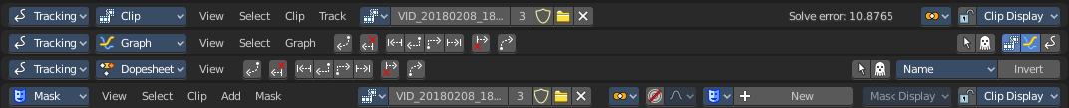
The Movie Clip Editor is three editors in one. And the Clip editor in mask mode looks also different. So we need to explain the content for all editor types plus the Mask mode that has a Select menu.
The Dope sheet mode has no Select menu.

Select Menu in Tracking mode in Clip sub mode

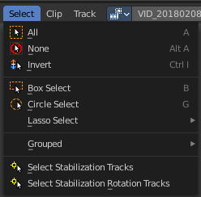
All
Select everything.

None
Select nothing.

Inverse
Invert the current selection.

Box Select
Draw a rectangle to box select markers.
It adds to selection by default. To subtract from selection hold down Shift key.

Circle Select
Circle select enters the Circle Select mode. This is a special select mode where you can select elements by moving with the mouse over it. It adds to selection by default.
To subtract from selection hold down Shift key. To exit the Circle select click with the right mouse button.
The pencil radius of the circle select tool can be adjusted with the scroll wheel.

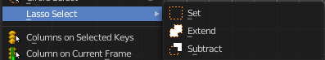
Lasso Select
A sub menu with the available lasso select modes.

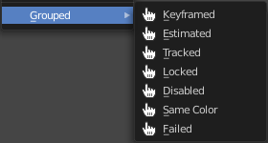
Grouped
Here you can select objects that are in the same group by the chosen method. The items should be self explaining.

Select Stabilization tracks
Select the tracks that are used for translation stabilization.

Select Stabilization Rotation tracks
Select the tracks that are used for rotation stabilization.

Select Menu in Tracking mode in Graph sub mode

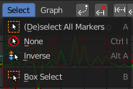
All
Select everything.

None
Select nothing.

Inverse
Invert the current selection.

Box Select
Draw a rectangle to box select markers.
It adds to selection by default. To subtract from selection hold down Shift key.

Select Menu in Mask mode
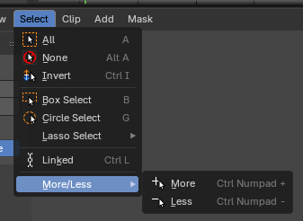
Note that you need to have a mask so that the content becomes active.

All
Select everything.

None
Select nothing.

Inverse
Invert the current selection.

Box Select
Draw a rectangle to box select markers.
It adds to selection by default. To subtract from selection hold down Shift key.

Circle Select
Circle select enters the Circle Select mode. This is a special select mode where you can select elements by moving with the mouse over it. It adds to selection by default.
To subtract from selection hold down Shift key. To exit the Circle select click with the right mouse button.
The pencil radius of the circle select tool can be adjusted with the scroll wheel.

Lasso Select
A sub menu with the available lasso select modes.

Linked
Select all curve points that are linked to the already selected points.

More/Less Submenu

More
Increase the selection by one point.

Less
Decrease the selection by one point.

